A FIELD PROJECT REPORT ON

**“Hostel Management System”**

Submitted in partial fulfilment of the requirements for the award of the degree

**BACHELOR OF TECHNOLOGY**

in

**COMPUTER SCIENCE ENGINNERING**

Submitted by

|  |  |
| --- | --- |
| V.Sai Venkat | (231FA04224) |
| T.Hemanth | (231FA04358) |
| P.Himasairam | (231FA04484) |
| A.Gnaneswar | (231FA04G07) |
|  |  |



Department of Computer Science engineering

School of Applied Science

Vignan’s Foundation for Science, Technology and Research (Deemed to be University) Vadlamudi, Guntur, Andhra Pradesh-522213, India

**March – 2025**



**CERTIFICATE**

This is to certify that the field project entitled “**Hostel Management System**” being submitted by (V.Sai Venkat & 231FA04224), (T. Hemanth & 231FA04358), (P.Himasairam & 231FA04484), and (A.Gnaneswar & 231FA04G07) in partial fulfilment of Bachelor of Technology in the Department of Computer Science engineering, Vignan’s Foundation For Science Technology & Research (Deemed to be University), Vadlamudi, Guntur District, Andhra Pradesh, India, is a bonafide work carried out by them under my guidance and supervision.

|  |  |
| --- | --- |
| **Head of the Department** | **Guide** |

**DECLARATION**

We hereby declare that our project work described in the field project titled “**Hostel Management System**” which is being submitted by us for the partial fulfilment in the department of Computer science enginnering, Vignan’s Foundation for Science, Technology and Research (Deemed to be University), Vadlamudi, Guntur, Andhra Pradesh, and the result of investigations are carried out by us under the guidance of (MR R.Prathap Kumar)

|  |  |  |
| --- | --- | --- |
| V.Sai Venkat | (231FA04224) | Signature |
| T. Hemanth | (231FA04358) | Signature |
| P.Himasairam | (231FA04484) | Signature |
| A.Gnaneswar | (231FA04G07) | Signature |

**Contents**

|  |  |  |
| --- | --- | --- |
| **Chapter No.** | **Description** | **Page No.** |
| **1** | **Introduction** |  |
| **2** | **Technologies Used** |  |
| **3** | **Project Description** |  |
| **4** | **Output** |  |
| **5** | **References** |  |

1. **Introduction:**

The **Hostel Management System** is a comprehensive web-based application designed to streamline hostel-related operations. This system offers an efficient way to manage hostel facilities, ensuring a smooth experience for both students and administrators. Built using **HTML, CSS, and JavaScript**, this platform provides an intuitive user interface and seamless functionality, reducing manual workload and improving efficiency.

**Objectives**

The primary goal of this system is to automate hostel management tasks such as student registration, hostel outpass approvals, vacating procedures, room allocation, and facility management. It ensures transparency and accessibility, allowing users to interact with the system conveniently.

**1.User Authentication Module:**

* Secure login system for students and administrators.
* Role-based access control to restrict unauthorized usage.
* Password encryption for enhanced security.

**2.Hostel Outpass Form**

* Enables students to request permission for temporary leave.
* Allows administrators to review and approve/reject requests.
* Provides a digital record of student movements.

**3. Hostel Vacating Form**

* Facilitates hostel vacating procedures.
* Ensures proper documentation and approval workflow.

**Facilities Management**

* Lists all hostel facilities available to students.

**5.Hostel Registration:**

* Simplifies the admission process for new students.
* Maintains student records and hostel allocation details.
* Generates confirmation receipts and room assignment details.

**Benefits of the System**

* **Automation**: Reduces manual workload and errors.
* **Transparency**: Provides real-time data access for students and administrators.
* **User-Friendly Interface**: Designed for easy navigation and usability.
* **Security**: Ensures student data protection and access control.
* **Efficiency**: Speeds up processes like approvals, room allocation, and maintenance tracking.

This **Hostel Management System** enhances hostel administration, offering a structured and systematic approach to managing accommodations efficiently. The integration of **HTML, CSS, and JavaScript** ensures a dynamic and responsive web application that meets modern hostel management needs.

**Technologies Used:**

Frontend: HTML, CSS, JavaScript Backend: PHP

Database: MySQL

Frameworks: Bootstrap (for responsive design)

The Hostel Management System is built using a combination of modern web technologies to ensure efficiency, scalability, and responsiveness. The key technologies used include:

**Frontend Technologies:**

* HTML (HyperText Markup Language): Defines the structure of web pages.
* CSS (Cascading Style Sheets): Enhances the visual presentation of the website.
* JavaScript: Provides interactive features and dynamic content.
* Bootstrap: A responsive framework used to design mobile-friendly and aesthetically appealing web pages.

### **Backend Technologies:**

**PHP (Hypertext Preprocessor)**: A server-side scripting language used for processing logic and handling database interactions.

**Database Management:**

MySQL: A relational database management system used to store and retrieve hostel-related data efficiently.

By integrating these technologies, the **Hostel Management System** ensures smooth operations, robust security, and an improved user experience.

**Technologies Used:**

Frontend: HTML, CSS, JavaScript Backend: PHP

Database: MySQL

Frameworks: Bootstrap (for responsive design)

The Hostel Management System is built using a combination of modern web technologies to ensure efficiency, scalability, and responsiveness. The key technologies used include:

**Frontend Technologies:**

* HTML (HyperText Markup Language): Defines the structure of web pages.
* CSS (Cascading Style Sheets): Enhances the visual presentation of the website.
* JavaScript: Provides interactive features and dynamic content.
* Bootstrap: A responsive framework used to design mobile-friendly and aesthetically appealing web pages.

### **Backend Technologies:**

**PHP (Hypertext Preprocessor)**: A server-side scripting language used for processing logic and handling database interactions.

**Database Management:**

MySQL: A relational database management system used to store and retrieve hostel-related data efficiently.

By integrating these technologies, the **Hostel Management System** ensures smooth operations, robust security, and an improved user experience.

**3.Project Description:**

**HTML Structure:**

The HTML files (**Login.html** and **index.html**) define the structure of the website. They include sections for:

* **Login Page:** Secure authentication system for students and administrators.
* **Hostel Registration Form:** Online application for hostel accommodation.
* **Hostel Vacating Form:** Submission of requests to vacate the hostel.
* **Hostel Outpass Form:** Request for permission to leave the hostel temporarily.
* **Room Details & Facilities:** Information about available hostel rooms and amenities.
* **Navigation:** A responsive navbar for easy access to different sections.

### **CSS Styling**

CSS files (**Loginstyles.css** and **style.css**) provide styling to the HTML elements. They define:

* Layout, colors, fonts, and overall responsiveness of the website.
* Styling for sections like login, hostel registration, vacating form, outpass form, and room details.
* Enhanced visual appeal for an intuitive user experience.

### **JavaScript Functionality:**

JavaScript is used for:

* **Form Validation:** Ensuring the correct format for email addresses and other inputs in the login and registration forms.
* **User Experience Enhancements:** Interactive elements to improve website usability.

### **Features & Functionality:**

1. **User Authentication:** Secure login system to prevent unauthorized access.

**2.Hostel Registration:** Students can apply for hostel accommodation online.

**3.Hostel Vacating Form:** Allows students to submit vacating requests with reason and approval status.

**4.Hostel Outpass Form:** Enables students to request temporary leave from the

hostel, specifying return time and reason.

**5.Room Details & Facilities:** Displays available hostel rooms, occupancy status, and amenities.

**6.Admin Dashboard (Future Enhancement):** Hostel authorities can manage student applications, approve outpasses, and maintain records.

**Expected Benefits:**

* **Efficiency:** Reduces paperwork and manual errors.
* **Convenience:** Students can submit requests from anywhere, reducing administrative workload.
* **Security:** Ensures only authorized users access hostel services.
* **Transparency:** Digital records provide easy tracking and management.

**Output:**

Login page:

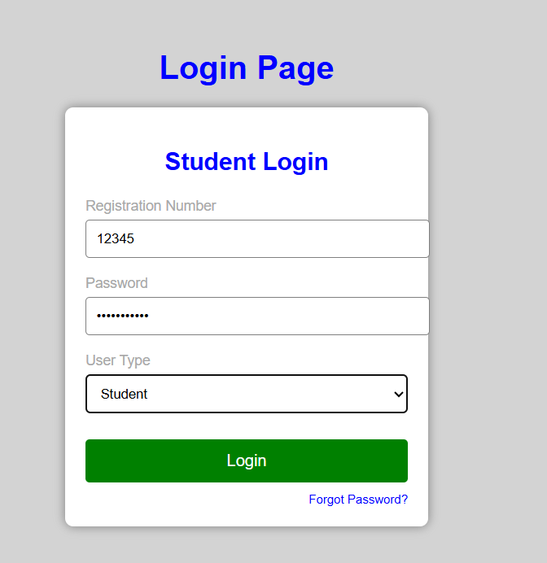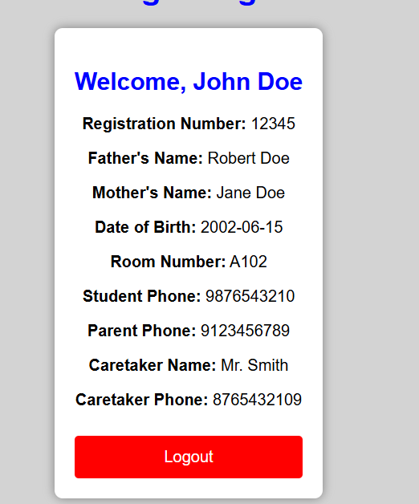

Hostel outpass form

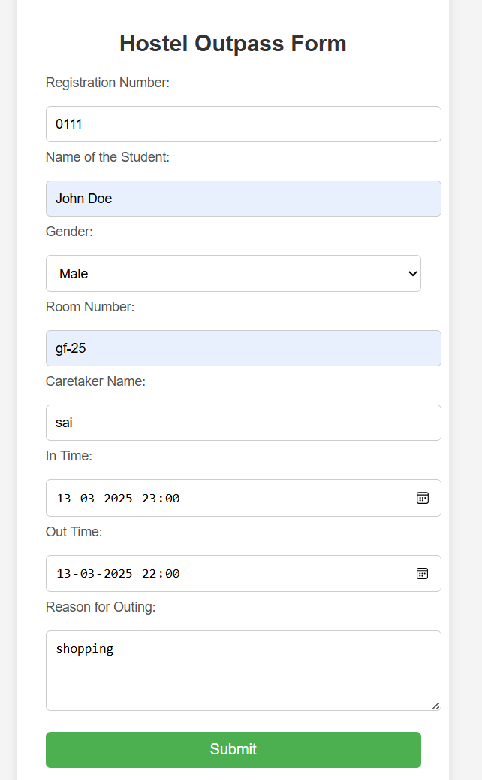

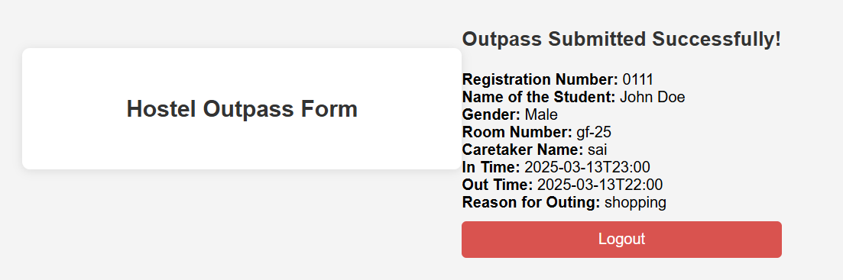

Hostel security login page:

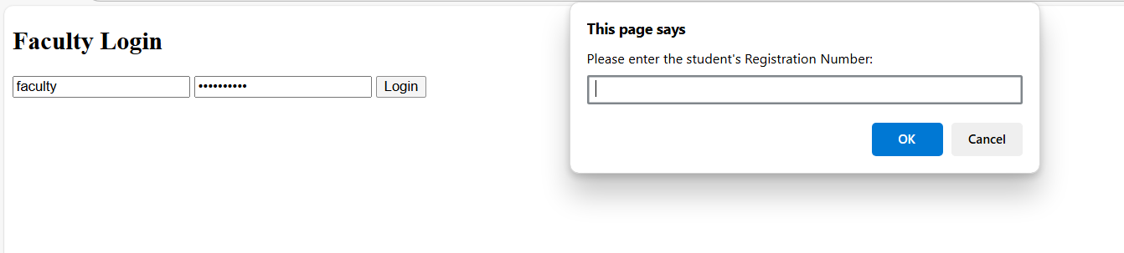

Hostel vacting form:

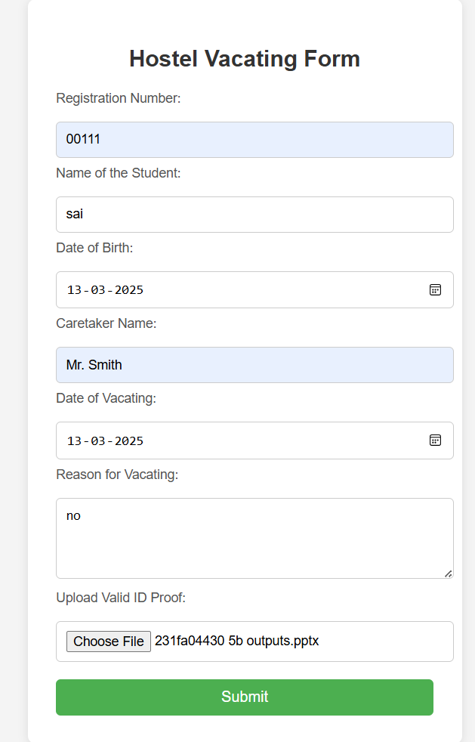 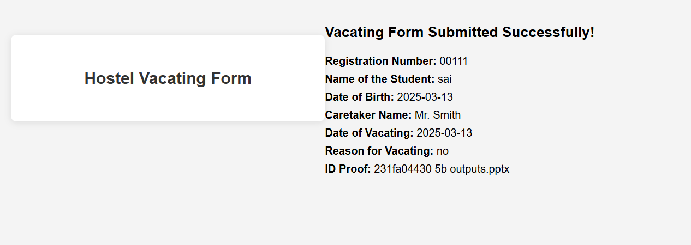

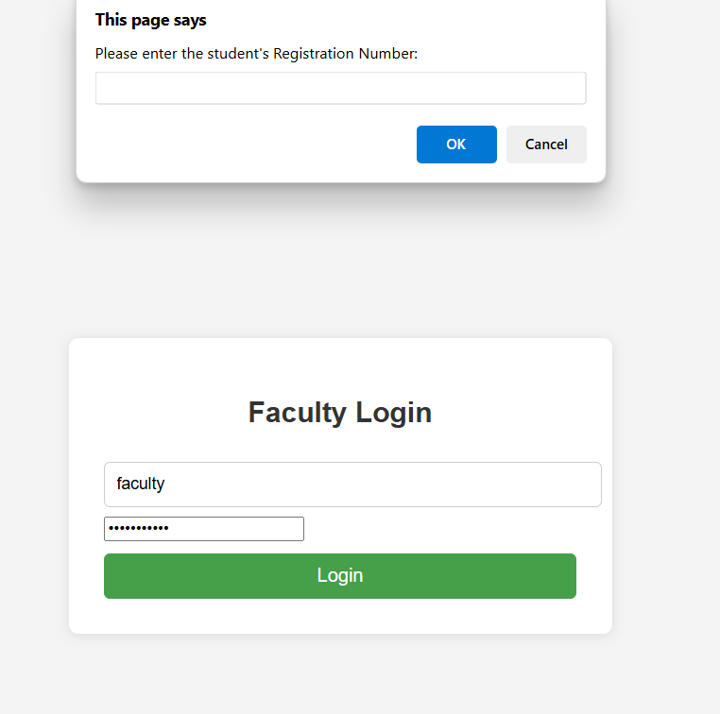 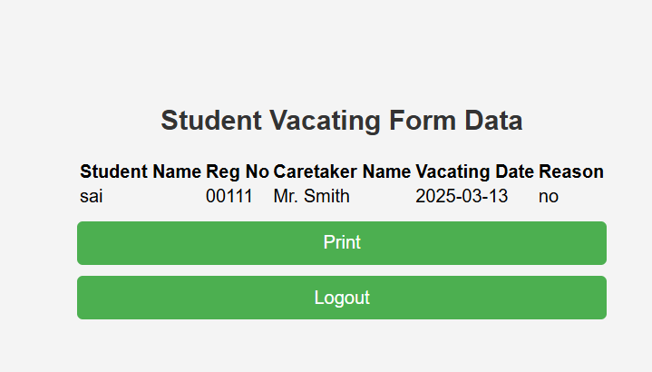

**Hostel Registration:**

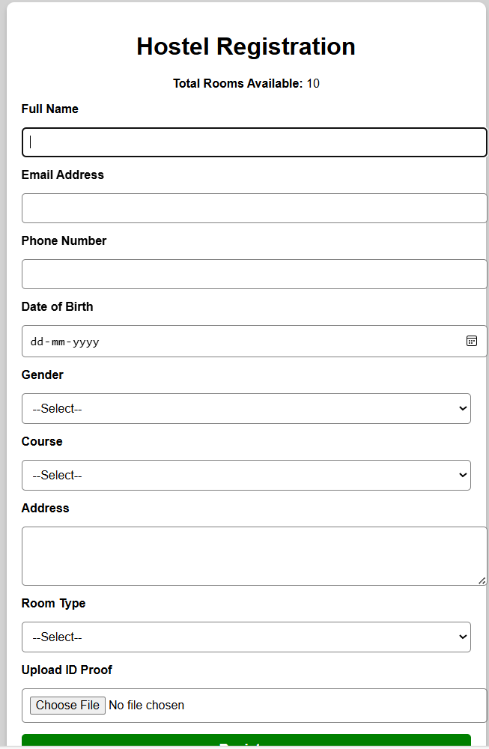 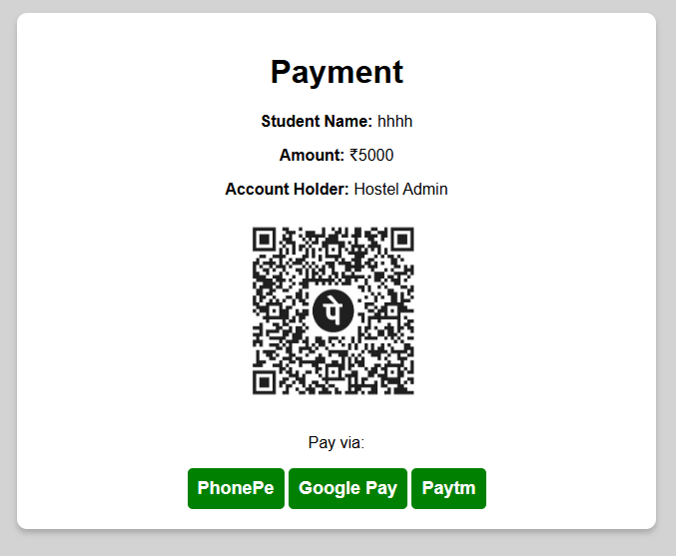

**Conclusion:**

The Hostel Management System streamlines the administration of hostel facilities by digitizing and automating key processes such as user authentication, hostel registration, outpass requests, vacating forms, and room details. By replacing manual record-keeping with an efficient digital platform, the system enhances accuracy, reduces paperwork, and improves accessibility for both students and administrators.

With features like secure authentication, real-time updates, and a user-friendly interface, this system ensures smooth hostel operations while minimizing errors and delays. Its implementation not only improves efficiency but also contributes to better resource management and student satisfaction. Further enhancements, such as mobile integration and advanced analytics, can be introduced to make the system even more robust and scalable.

**Project Link:**

https://github.com/sairampentela/Vignan-Hostel2